# Flow Documentation - new/replacement

|  |  |
| --- | --- |
| **Flow Name** | new/replacement |
| **Flow ID** | b089f882-2aed-4167-a21f-0468663e7ceb |
| **Documentation generated at** | 22 July 2023 10:07 |
| **Number of Variables** | 1 |
| **Number of Actions** | 9 |

## Flow Overview

The following chart shows the top level layout of the Flow. For a detailed view, please visit the section called Detailed Flow Diagram

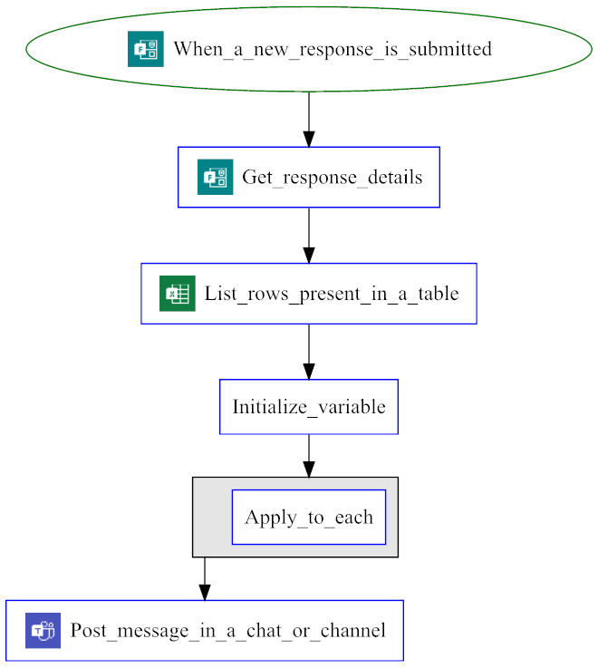

## Connections

There are a total of 3 connections used in this Flow:

### Microsoft Forms

|  |  |  |  |
| --- | --- | --- | --- |
| **Connector** | |  |  | | --- | --- | |  | [Microsoft Forms](https://docs.microsoft.com/connectors/microsoftforms) | |
| **Connection Type** | Connector |
| **ID** | shared_microsoftforms |
| **Source** | Embedded |

### Excel Online (Business)

|  |  |  |  |
| --- | --- | --- | --- |
| **Connector** | |  |  | | --- | --- | |  | [Excel Online (Business)](https://docs.microsoft.com/connectors/excelonlinebusiness) | |
| **Connection Type** | Connector |
| **ID** | shared_excelonlinebusiness |
| **Source** | Embedded |

### Microsoft Teams

|  |  |  |  |
| --- | --- | --- | --- |
| **Connector** | |  |  | | --- | --- | |  | [Microsoft Teams](https://docs.microsoft.com/connectors/teams) | |
| **Connection Type** | Connector |
| **ID** | shared_teams |
| **Source** | Embedded |

## Variables

### counter

|  |  |
| --- | --- |
| **Name** | counter |
| **Type** | integer |
| **Initial Value** | |  |  | | --- | --- | | **0** |  | |
| **Used in these Actions** | Condition_3  Initialize_variable  Set_variable_2 |

## Trigger

|  |  |
| --- | --- |
| **Name** | When_a_new_response_is_submitted |
| **Type** | OpenApiConnectionWebhook |
| **Connector** | microsoftforms |
| **Inputs Details** | |
| **host** | |  |  | | --- | --- | | apiId | /providers/Microsoft.PowerApps/apis/shared_microsoftforms | | connectionName | shared_microsoftforms | | operationId | CreateFormWebhook | |
| **parameters** | |  |  | | --- | --- | | form_id | epiJLMf1xkqTd4q-EaCLuBwp4QcTX-1HhCNGGhbZWNlUREVJMkdNMVNaRlhTWjk5UVdZUVdRVFBaVC4u | |
| **authentication** | @parameters('$authentication') |
| **Other Trigger Properties** | |
| **splitOn** | @triggerOutputs()?['body/value'] |
| **metadata** | |  |  | | --- | --- | | operationMetadataId | 3fdbb19d-47e6-491e-91ed-c7e425f50695 | |

## Actions

There are a total of 9 actions used in this Flow:

### Apply_to_each

|  |  |
| --- | --- |
| **Name** | Apply_to_each |
| **Type** | Foreach |
| **Inputs** | |
| **foreach** | @outputs('List_rows_present_in_a_table')?['body/value'] |
| **metadata** | |  |  | | --- | --- | | operationMetadataId | 9b5cbad5-9e8b-4a3f-b9c3-4398bc4491e5 | |
| **Subactions** | Condition |
| **Next Action(s) Conditions** | Post_message_in_a_chat_or_channel [Succeeded] |

### Condition

|  |  |
| --- | --- |
| **Name** | Condition |
| **Type** | If |
| **Expression** | |  |  |  |  |  |  | | --- | --- | --- | --- | --- | --- | | or | |  |  | | --- | --- | | equals | @items('Apply_to_each')?['HasLeftTheOrganization']  Open |  |  |  | | --- | --- | | equals | @items('Apply_to_each')?['HasLeftTheOrganization']  No | | |
| **Inputs** | |
| **metadata** | |  |  | | --- | --- | | operationMetadataId | 300dc386-8a5f-45d9-9437-a1c903ce0210 | |
| **Subactions** | Condition_2 |

### Condition_2

|  |  |
| --- | --- |
| **Name** | Condition_2 |
| **Type** | If |
| **Expression** | |  |  | | --- | --- | | equals | @items('Apply_to_each')?['Projectname']  @outputs('Get_response_details')?['body/reba3dffb0a3447d9bc7e8356e6e87c56'] | |
| **Inputs** | |
| **metadata** | |  |  | | --- | --- | | operationMetadataId | 53c0733b-9ac5-4f1f-a267-6374b9f38060 | |
| **Subactions** | Condition_3 |

### Condition_3

|  |  |
| --- | --- |
| **Name** | Condition_3 |
| **Type** | If |
| **Expression** | |  |  | | --- | --- | | greater | @items('Apply_to_each')?['Number']  @variables('counter') | |
| **Inputs** | |
| **metadata** | |  |  | | --- | --- | | operationMetadataId | 53c0733b-9ac5-4f1f-a267-6374b9f38060 | |
| **Subactions** | Set_variable_2 |

### Get_response_details

|  |  |
| --- | --- |
| **Name** | Get_response_details |
| **Type** | OpenApiConnection |
| **Connection** | |  |  | | --- | --- | |  | [Microsoft Forms](https://docs.microsoft.com/connectors/microsoftforms) | |
| **Inputs** | |
| **metadata** | |  |  | | --- | --- | | operationMetadataId | 5f537d5f-daa6-48e3-a214-23886ea93a62 | |
| **host** | |  |  | | --- | --- | | apiId | /providers/Microsoft.PowerApps/apis/shared_microsoftforms | | connectionName | shared_microsoftforms | | operationId | GetFormResponseById | |
| **parameters** | |  |  | | --- | --- | | form_id | epiJLMf1xkqTd4q-EaCLuBwp4QcTX-1HhCNGGhbZWNlUREVJMkdNMVNaRlhTWjk5UVdZUVdRVFBaVC4u | | response_id | @triggerOutputs()?['body/resourceData/responseId'] | |
| **authentication** | @parameters('$authentication') |
| **Next Action(s) Conditions** | List_rows_present_in_a_table [Succeeded] |

### Initialize_variable

|  |  |
| --- | --- |
| **Name** | Initialize_variable |
| **Type** | InitializeVariable |
| **Inputs** | |
| **metadata** | |  |  | | --- | --- | | operationMetadataId | 2d00a60c-cf81-43a4-b243-34e94780a120 | |
| **variables** | |  |  | | --- | --- | | name | counter | | type | integer | | value | 0 | |
| **Next Action(s) Conditions** | Apply_to_each [Succeeded] |

### List_rows_present_in_a_table

|  |  |
| --- | --- |
| **Name** | List_rows_present_in_a_table |
| **Type** | OpenApiConnection |
| **Connection** | |  |  | | --- | --- | |  | [Excel Online (Business)](https://docs.microsoft.com/connectors/excelonlinebusiness) | |
| **Inputs** | |
| **metadata** | |  |  | | --- | --- | | 01XFZUCKSXAQPB7KNLDZGKBRUGFU74QY5F | /Recruitment/Resources Needed/Requisition1.xlsx | | operationMetadataId | cba725bd-61be-42f4-a4a9-b5a83e300783 | | tableId | {00000000-000C-0000-FFFF-FFFF00000000} | |
| **host** | |  |  | | --- | --- | | apiId | /providers/Microsoft.PowerApps/apis/shared_excelonlinebusiness | | connectionName | shared_excelonlinebusiness | | operationId | GetItems | |
| **parameters** | |  |  | | --- | --- | | source | groups/a4e930cc-25dc-4635-901a-264413185b94 | | drive | b!6zCLhzwwXkmRg1Vv6qgzIqniyIUYUnlAsRW910HzA436Z6o5335USbByNPN0PU5a | | file | 01XFZUCKSXAQPB7KNLDZGKBRUGFU74QY5F | | table | {00000000-000C-0000-FFFF-FFFF00000000} | |
| **authentication** | @parameters('$authentication') |
| **Next Action(s) Conditions** | Initialize_variable [Succeeded] |

### Post_message_in_a_chat_or_channel

|  |  |
| --- | --- |
| **Name** | Post_message_in_a_chat_or_channel |
| **Type** | OpenApiConnection |
| **Connection** | |  |  | | --- | --- | |  | [Microsoft Teams](https://docs.microsoft.com/connectors/teams) | |
| **Inputs** | |
| **metadata** | |  |  | | --- | --- | | operationMetadataId | 1b99c216-426f-4de0-9029-fb29d25e881e | |
| **host** | |  |  | | --- | --- | | apiId | /providers/Microsoft.PowerApps/apis/shared_teams | | connectionName | shared_teams | | operationId | PostMessageToConversation | |
| **parameters** | |  |  | | --- | --- | | poster | Flow bot | | location | Group chat | | body/recipient | 19:a02e9a23342e49cc8822dbfb9aabec62@thread.v2 | | body/messageBody | <p>new highhest count is @{variables('counter')}</p> | |
| **authentication** | @parameters('$authentication') |

### Set_variable_2

|  |  |
| --- | --- |
| **Name** | Set_variable_2 |
| **Type** | SetVariable |
| **Inputs** | |
| **metadata** | |  |  | | --- | --- | | operationMetadataId | 0dbdf0d3-1f35-41e7-95fa-e1acc0e72f82 | |
| **name** | counter |
| **value** | @items('Apply_to_each')?['Number'] |

## Detailed Flow Diagram

The following chart shows the detailed layout of the Flow

